Additional Information

The Comic Book Series: Heroes and Super- Villains

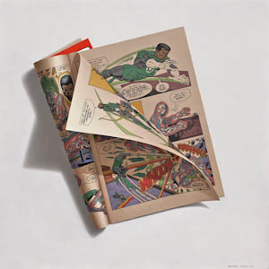
Goin’ Up! 16X16 in., oil on panel, 2011
Green Lantern, Vol. 21, No. 165, June 1983
Produced by Mike W. Barr, writer; Keith Pollard, pencil artist;
Dan Adkins, ink artist; P. Felix, Letterer; G. D’Angelo, colorist;
Ernie Colon, editor.

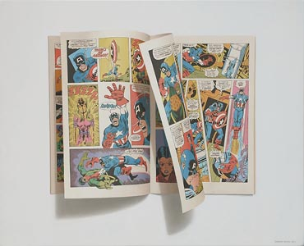
Sharon! 16X20 in., oil on panel, 2011
Captain America, Vol. 1, No. 147, March 1972
Stan Lee, editor; Gary Friedrich, writer; Sal Buscema,
penciller; John Verpoorten, Inker; Artie Simek, letterer

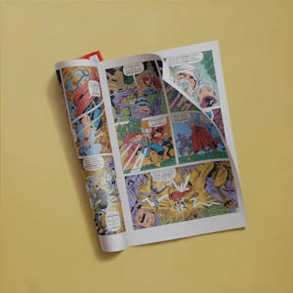
Mjolnir - - To Thy Master! 16X16, oil on panel, 2011
Thor, Vol. 1, No. 172, January 1970
Written and drawn by Stan Lee and Jack Kirby; Bill Everett,
embellisher; Art Simek, letterer

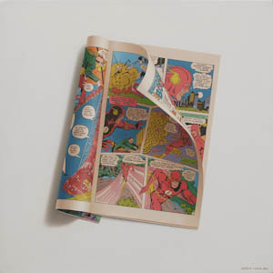
Mach I, 16X16, oil on panel, 2011
The Flash, Vol. 31, No. 272, April 1979
Writer: Cary Bates, Pencils: John Calnan & Rich Bucker,
Inker: Vince Coletta, Letterer: Ben Oda, Coloring: Gene
D’Angelo, Editor: Ross Andru

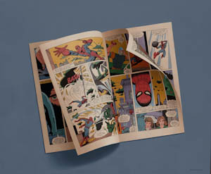
Bash Krash, 18X24 in., oil on panel, 2011
Spiderman and Wolverine, Vol. 1, No. 117, May, 1982
Story: J.M. Dematteis, Art, Herb Trimpe Mike Esposito,
Letter: Joe Rosen, Color: Bob Sharen, Editor: Tom
DeFalco, Editor-in-Chief: Jim Shooter

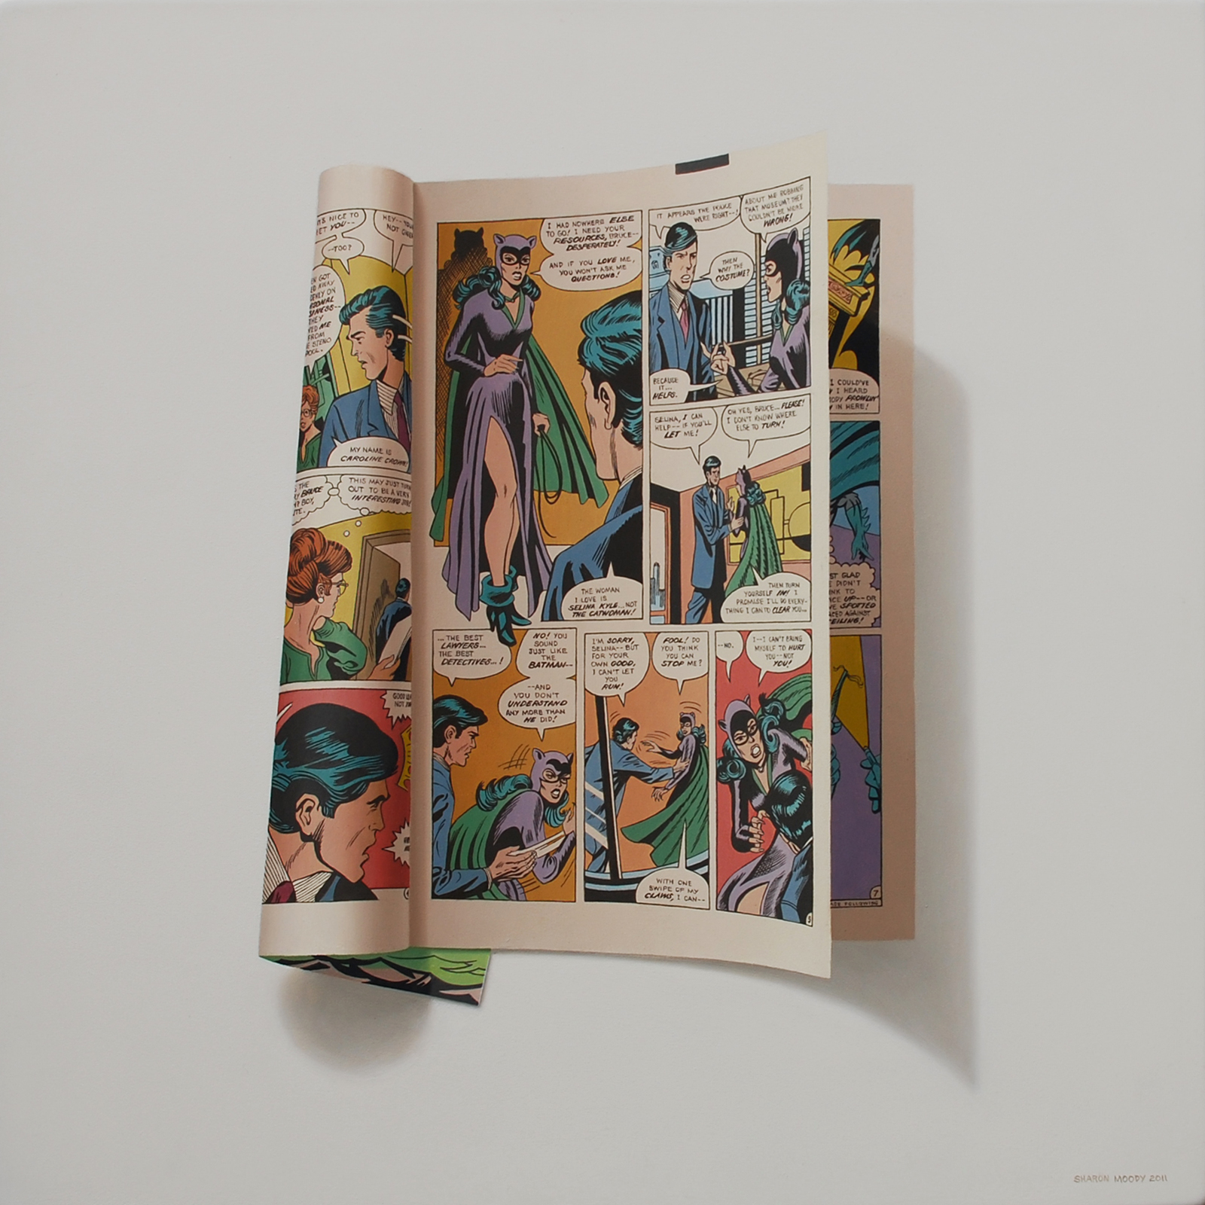
If You Love Me, 16X16, oil on panel, 2011
Batman, Vol. 41, No. 323, May, 1980
Len Wein, writer; Irv Novick and Bob Smith, artists; Glynis
Wein, colorist; Ben Oda, letterer; Paul Levitz, editor

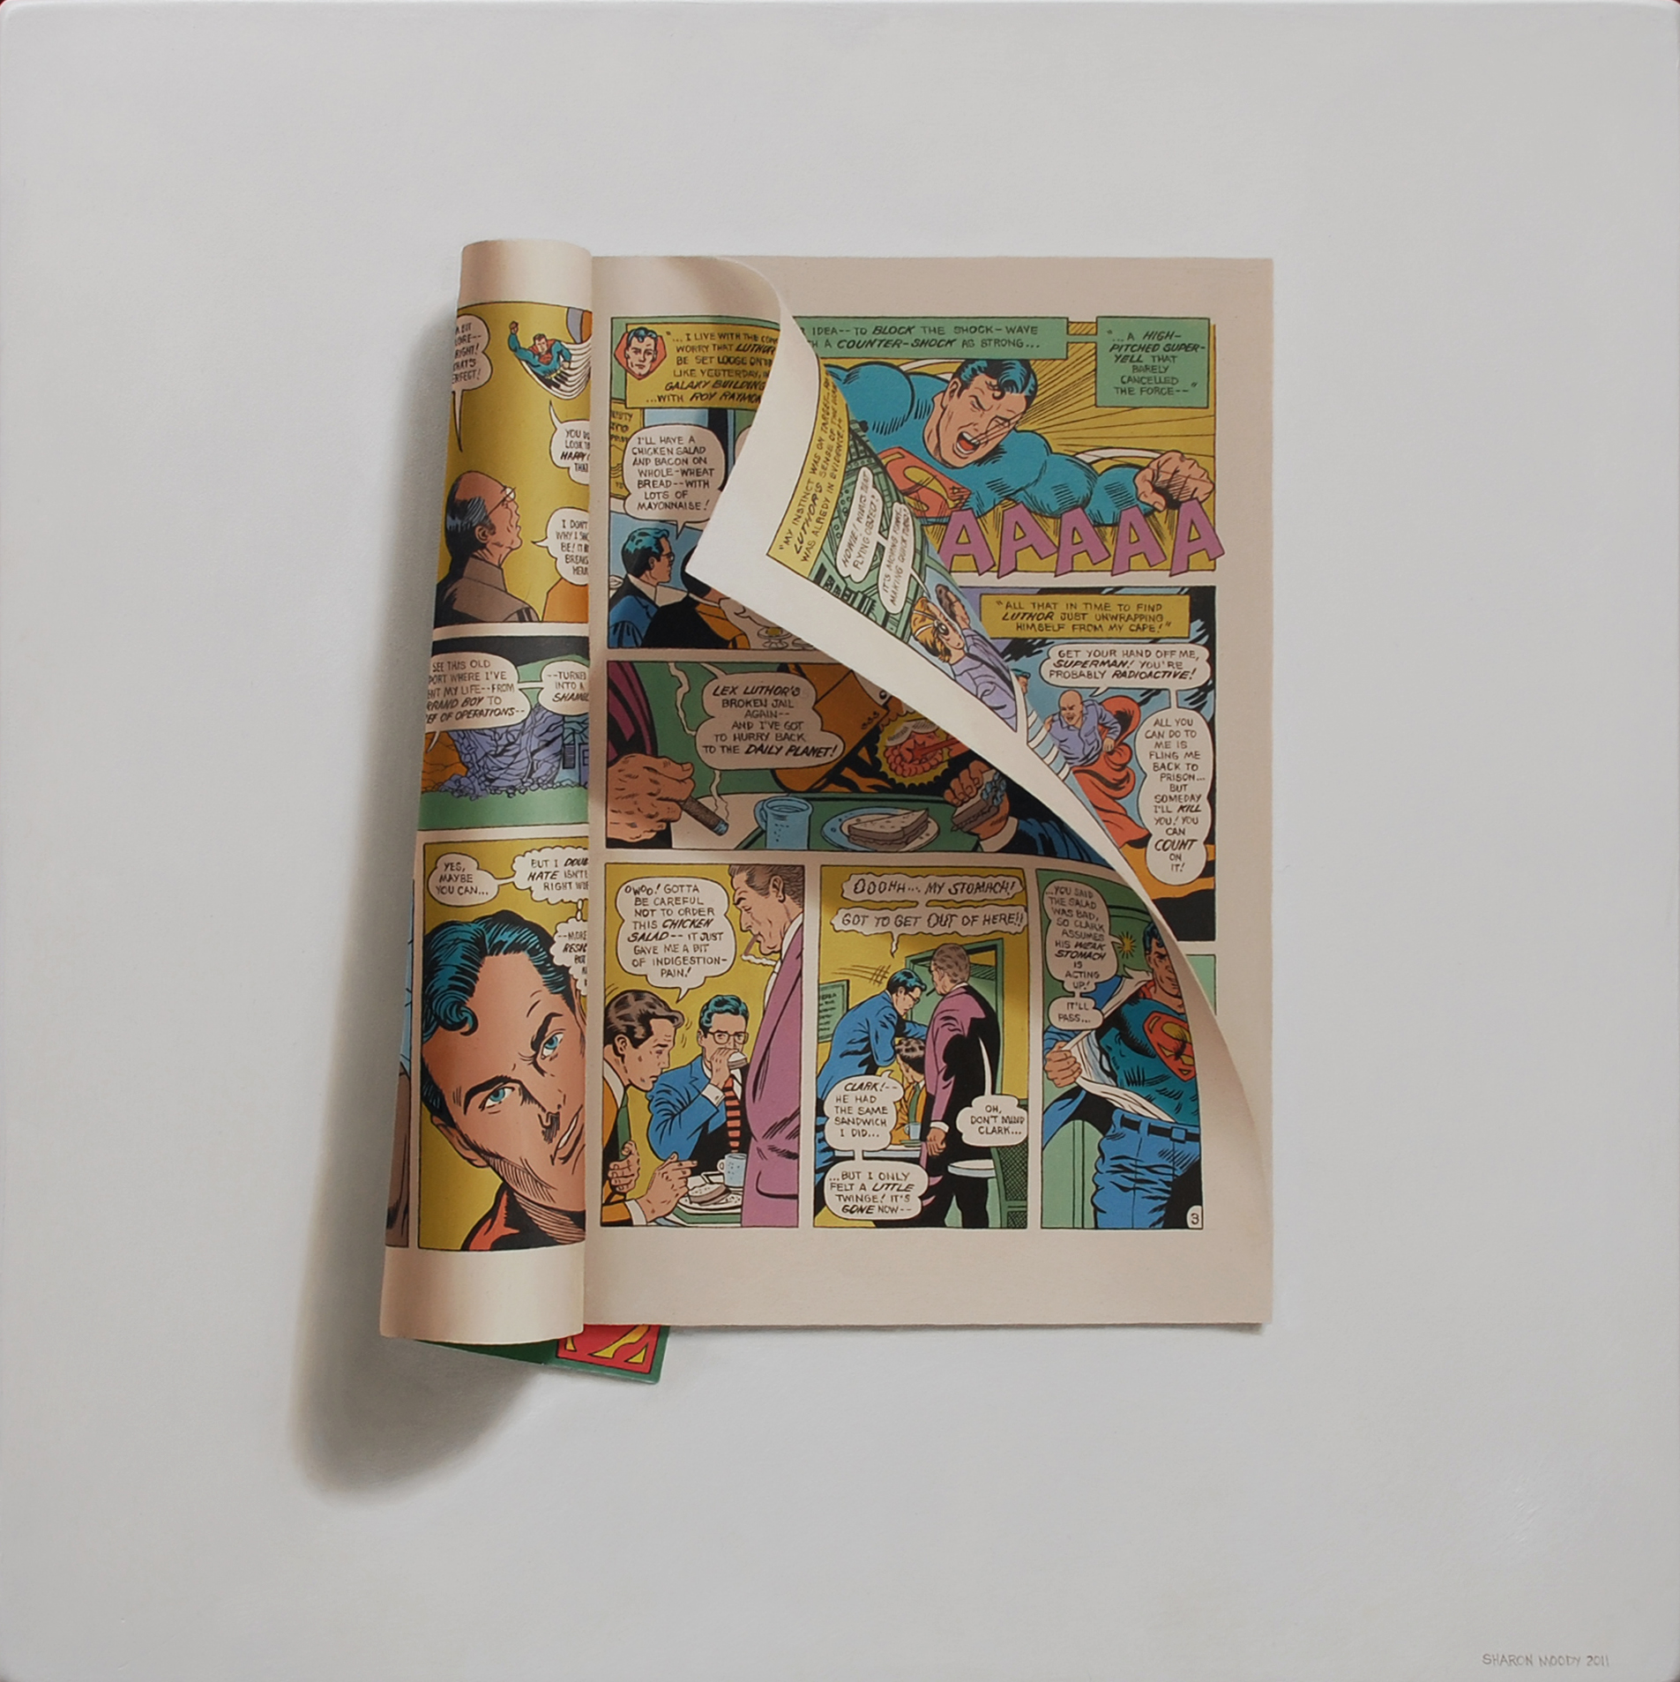
Don’t Mind Clark, 16X16, oil on panel, 2011
Superman, Vol. 37, No. 292, October 1975
Elliot S. Maggin, writer; Curt Swan & Bob Oksner, artists;
Julius Schwartz, editor

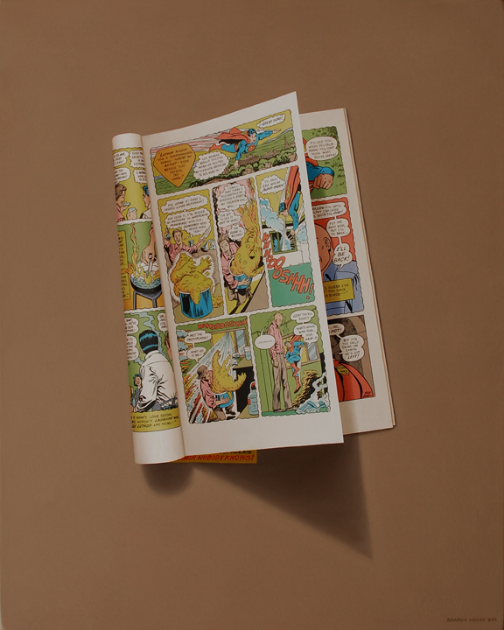
Whhooooshhh! 20X16, oil on panel, 2011
Superman, Vol. 37, No. 292, October 1975
Elliot S. Maggin, writer; Curt Swan & Bob Oksner, artists;
Julius Schwartz, editor

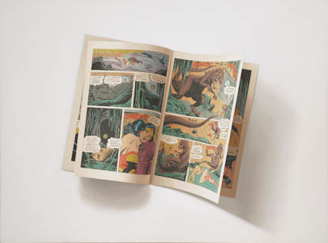
Merciful Minerva! 18X24 in., oil on panel, 2011
Wonder Woman, Vol. 39, No. 265, March 1980
Gerry Conway, writer; Jose Delbo, artist; Joe Giella,
inker; Milt Snapinn, letterer; Herry Serpe, colorist; Ross
Andru, editor

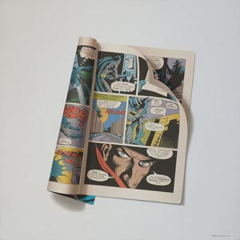
The Shadow! 16X16 in., oil on panel, 2011
Batman, Vol. 34, No. 253, November 1973
Denny O’Neil, writer; Irv Novic and Dick Giordano, artists;
Julius Schwartz, editor

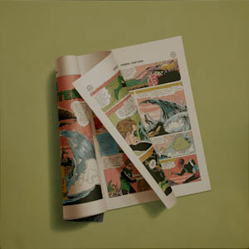
A Great Wave, 16X16 in., oil on panel, 2011
Green Lantern, No. 24, October 1963
Julius Schwartz, editor

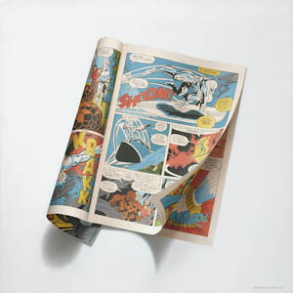
Slam! Krakk! Shoom! Thripp! 16X16, oil on panel, 2011
Fantastic Four, Vol. 1, No. 55, October 1966
Written by Stan Lee, pencilled by Jack Kirby, delineated by
Joey Sinnott, lettered by Sammy Rosen, edited by Irving
Forbush

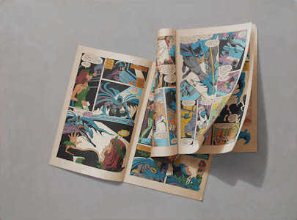
Hit the Spots! 18X24, oil on panel, 2011
Batman,Vol. 42, No. 336, June 1981
Bob Rozakis, plot; Roy Thomas, script; Jose Garcia-
Lopez and Frank McLaughlin, artists; John Costanza,
letterer; Adrienne Roy, colorist; Paul Levitz, editor
and Batman, Vol. 42, No. 339, September 1981
Gerry Conway, writer; Irv Novick and Steve Mitchell,
artists; Ben Oda, letterer; Adrienne Roy, colorist; Dick
Giordano, editor

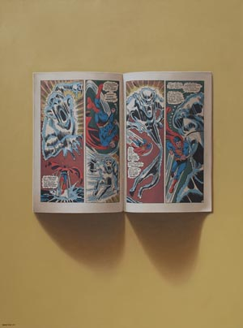
Judging From its Jagged Shape, 24X18 in., oil on panel, 2010
World’s Finest, No. 203, June, 1971
Written by Steve Skeates; illustrated by Dick Dinnin and Joe
Giella; edited by Julius Schwartz

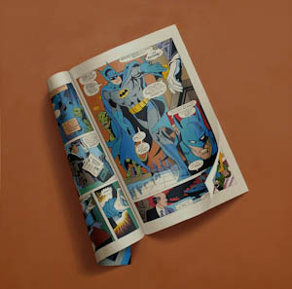
The Batman! 16X16, oil on panel, 2010
Batman,Vol. 42, No. 336, June 1981
Bob Rozakis, plot; Roy Thomas, script; Jose Garcia-Lopez and
Frank McLaughlin, artists; John Costanza, letterer; Adrienne
Roy, colorist; Paul Levitz, editor

